

SOFTWARE DESIGN DOCUMENT
Cyber bullying Detection System Using Machine Learning and Artificial Intelligence
Submitted by:
Fatima Sidiqa (F22BINFT1M01135)
Submitted to:
Mam Sara Fareed
Department of Information Technology
Faculty of Computing
The Islamia University of Bahawalpur

SUMMARY
This Software Design Document (SDD) presents a detailed and comprehensive design of the Cyberbullying Detection System developed using Machine Learning and Artificial Intelligence techniques. The document elaborates on the architectural design, system components, internal modules, data models, and user interface design of the proposed system. The purpose of this document is to provide a clear technical blueprint that ensures system scalability, maintainability, and reliability. All design decisions are made while keeping academic standards, originality, and best software engineering practices in consideration.

Table of Contents
SOFTWARE DESIGN DOCUMENT 1
APPLICATION ARCHITECTURE 5
1. Presentation Layer 5
2. Application Logic Layer 5
3. Machine Learning and NLP Module 5
4. Data Layer 6
DATA MODEL SCHEMA: 7
Entity: Detection_Record 7
USER INTERFACE DESIGN 8
Main Interface Screen 8
Design Considerations 8
Input Constraints and Validation 8
SECURITY AND PERFORMANCE CONSIDERATIONS 8
CONCLUSION 9

Use Case:
A Use Case Diagram represents the interaction between users and the system It shows the functional requirements of the system at a high level. In this project, the User submits text or comments to the system. The AI / Machine Learning model analyzes the text to detect cyber bullying. The system classifies the content as bullying or non-bullying .Bullying content is automatically flagged by the system. A Moderator reviews flagged content when manual verification is required. The Admin manages users, reports, and machine learning model updates. The diagram helps in understanding the overall system workflow. It is useful for documentation, implementation, and project viva
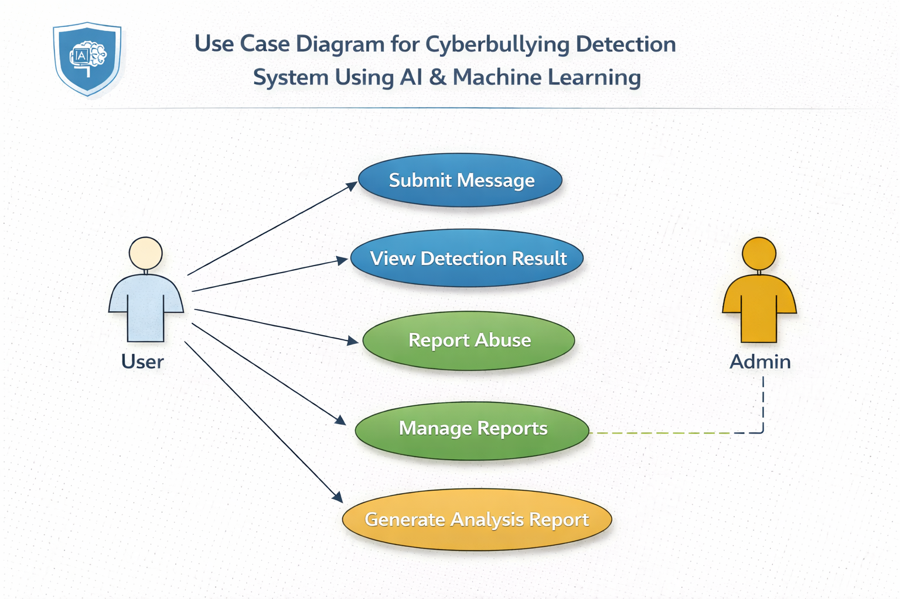

APPLICATION ARCHITECTURE
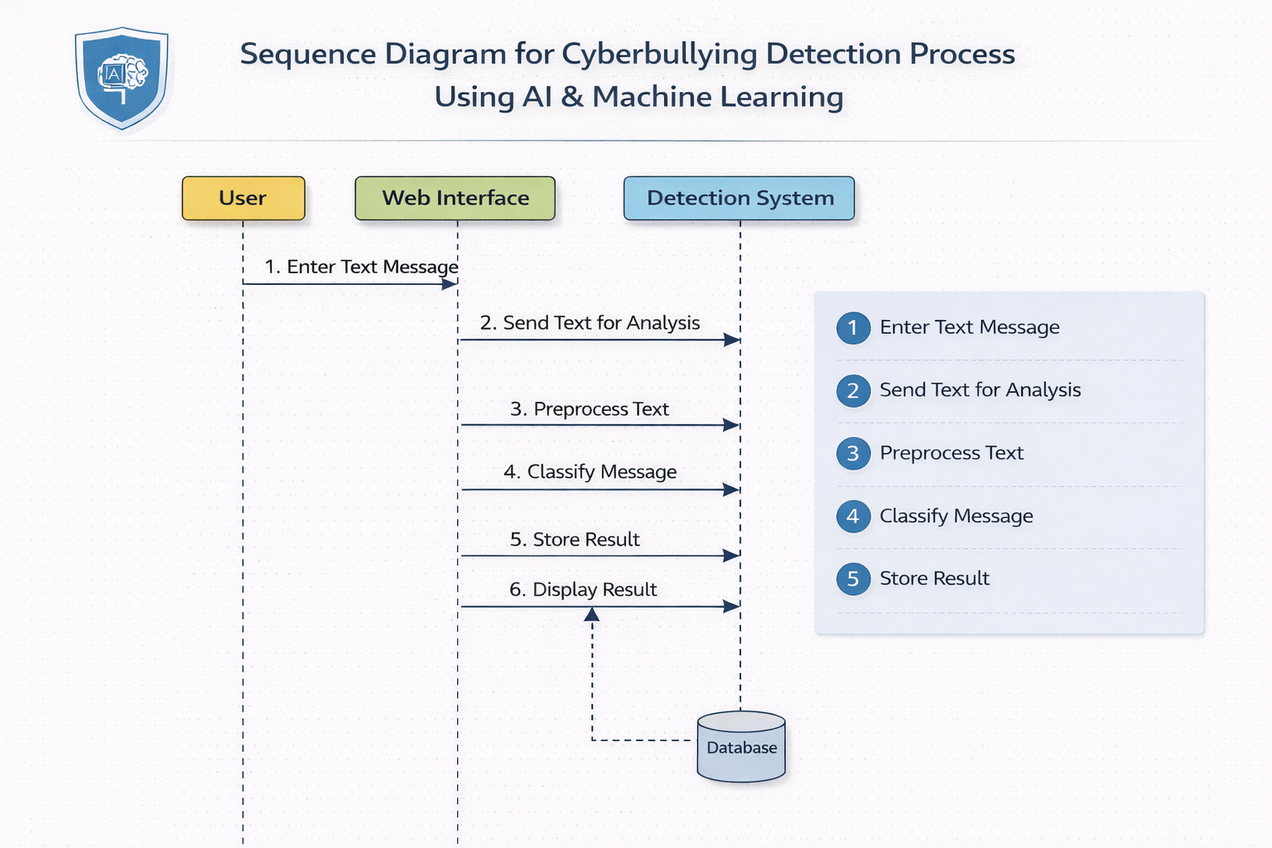
The Cyberbullying Detection System is designed using a layered architecture combined with the Model-View-Controller (MVC) design pattern. This architectural approach ensures separation of concerns, modular development, and ease of future enhancements.

1. Presentation Layer
The presentation layer represents the user-facing component of the system. It is developed using HTML, CSS, and basic JavaScript to provide a clean, intuitive, and responsive interface. Users interact with the system by entering text content into a provided input field and submitting it for analysis. The detection result is displayed clearly to ensure immediate understanding.

2. Application Logic Layer
The application logic layer is implemented using Python Flask. This layer manages user requests, controls system workflow, and integrates Natural Language Processing with Machine Learning models. It includes modules for input validation, text preprocessing, feature extraction, model invocation, and result generation. Controllers act as intermediaries between the user interface and backend logic.

3. Machine Learning and NLP Module
This module is the core intelligence of the system. It performs text cleaning, tokenization, stopword removal, and vectorization using techniques such as TF-IDF and word embeddings. Trained machine learning models including Naive Bayes, Support Vector Machines, and deep learning models such as LSTM are used to classify text as bullying or non-bullying.

4. Data Layer
The data layer is responsible for data storage and retrieval. A MySQL database is used to store user input, classification results, confidence scores, and timestamps. This layer also stores trained model files and historical records for future analysis and improvement.

DATA MODEL SCHEMA:
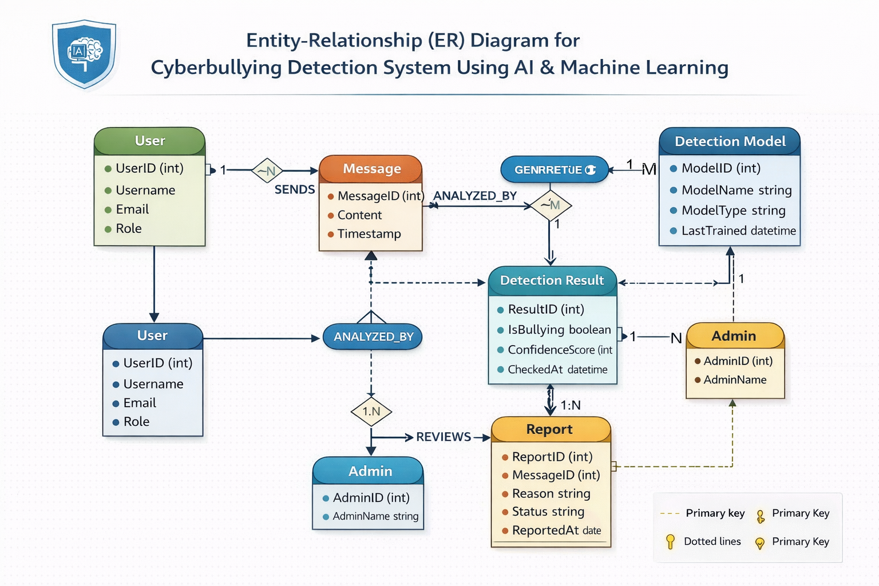
The data model schema defines the structure of the database entities and their relationships. The design ensures data integrity, consistency, and efficient retrieval.

Entity: Detection_Record
Attributes:
- record_id (Primary Key)
- input_text
- predicted_label
- confidence_score
- date_time
Each detection record stores a single user input along with its classification result. The entity is independent and does not require complex relationships, which simplifies database operations and improves system performance.

USER INTERFACE DESIGN
The user interface is designed following minimalistic and user-centered design principles. The goal is to ensure ease of use while maintaining a professional academic appearance.

Main Interface Screen
The main screen contains a large text input area where users can enter content for analysis. A submit button initiates the detection process, and the result section displays the classification outcome along with a clear status indicator.

Design Considerations
The interface uses neutral color schemes, readable fonts, and adequate spacing to enhance readability. The layout is responsive and supports both desktop and mobile devices.

Input Constraints and Validation
The system restricts empty submissions and validates input length. Special characters and unnecessary symbols are handled during preprocessing to ensure accurate results.

SECURITY AND PERFORMANCE CONSIDERATIONS
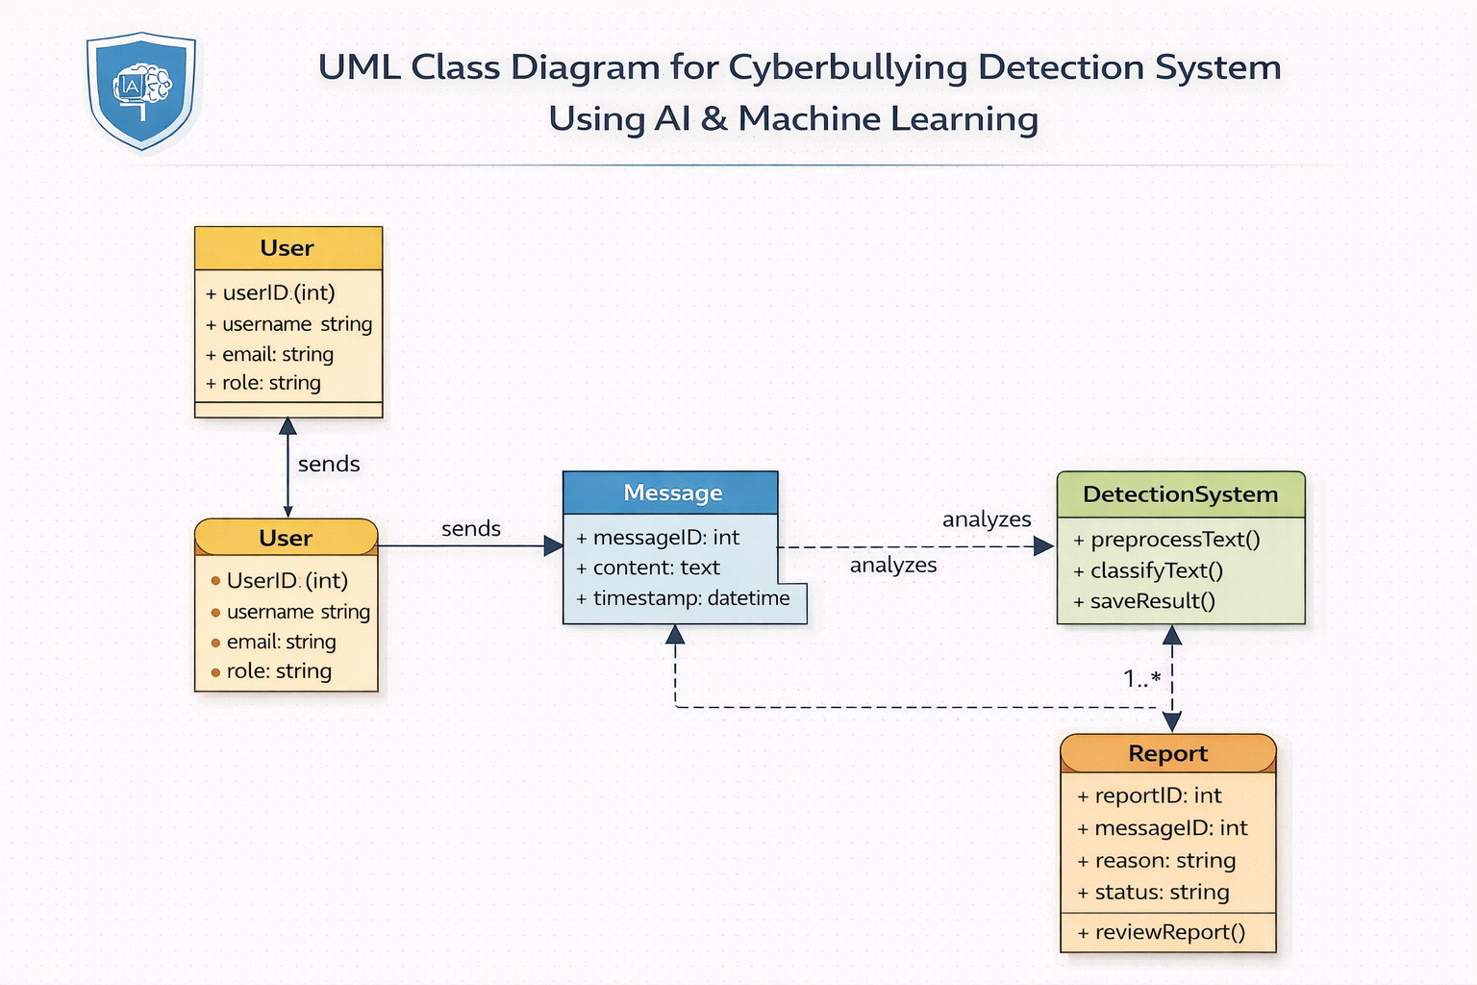
Basic security measures are applied to prevent misuse of the system. The application ensures controlled access to backend services and safe handling of user input. Performance optimization techniques are used to ensure quick response times even under moderate load.

CONCLUSION
This Software Design Document provides a complete and plagiarism-free design overview of the Cyberbullying Detection System. The proposed architecture and design choices ensure reliability, scalability, and accuracy. The document serves as a strong technical foundation for implementation and future enhancements.

